**GREENING THE FIELDS**

By

Srikanth

      Thesis submitted to the Faculty of the Graduate School of the

  in fulfillment of the requirements for GRAD 695 of the

Computer and Information Sciences program

Supervised by: Abrar Qureshi, Ph.D.

[Spring 2024]

**Abstract:**

This project, named "Greening the Fields," studies new ways to improve farming across various soil types, with a special focus upon red, black, and rock soils. The key objective is to figure out how we can help farmers grow more crops with both increasing earnings and protecting the environment. To do so, we studied the issues that farmers face, such as how certain soils make it difficult for farmers to grow crops or how farming, especially in certain places, is expensive and currently provides little profit. We spoke with farmers to learn about their experiences and tested the soil to determine its quality and requirements.

The research we conducted suggested that using modern farming methods and technology, such as equipment to evaluate soil health or irrigation systems to water crops effectively, may be beneficial. I also observed that determining which crops to grow and utilizing organic techniques to enhance soil could have a significant impact. We gave these innovative ideas and learnt from one another while working with farmers in workshops.

The main outcomes suggest it is possible to produce healthier crops while saving resources like water and fertilizer. This means that farmers may earn more while minimizing environmental impact. The study indicates that similar methods may be used in other areas, making farming more efficient and sustainable worldwide.

In brief, "Greening the Fields" proposes novel solutions to previous problems, with the goal of increasing agricultural productivity and preserving the environment. This study not only provides useful suggestions for farmers, but it also contributes to the wider conversation about how to cultivate in a manner that is beneficial for the environment.

**Table of Contents**

1. Introduction............................................................................................................. 5

    1.1 Purpose................................................................................................................ 5

    1.2 Scope................................................................................................................... 6

    1.3 Overview............................................................................................................. 6

2. Background and Motivation................................................................................... 7

   2.1 Importance of Sustainable Agriculture.............................................................. 8

   2.2 Challenges in Agricultural Practices Across Soil Types .................................... 9

   2.3 Personal Inspiration and Research Objectives ................................................. 11

3. Literature Review................................................................................................... 13

   3.1 Sustainable Farming Practices ........................................................................... 13

   3.2 Technological Innovations in Agriculture.......................................................... 14

   3.3 Gap Analysis and Research Opportunities ........................................................ 14

4. Methodology .......................................................................................................... 15

   4.1 Research Design and Approach ......................................................................... 15

   4.2 Data Collection Methods ................................................................................... 15

       4.2.1 Interviews with Farmers ............................................................................. 16

       4.2.2 Soil Analysis and Field Trials ..................................................................... 17

   4.3 Analytical Framework ....................................................................................... 17

5. Findings .................................................................................................................. 17

   5.1 Insights from Farmer Interviews ....................................................................... 18

   5.2 Results of Soil Analysis ...................................................................................... 18

   5.3 Challenges Identified Across Different Soil Types............................................. 23

6. Solutions and Innovation ....................................................................................... 24

   6.1 Precision Agriculture Practices .......................................................................... 24

   6.2 Integration of Modern Technologies ................................................................. 25

       6.2.1 Soil Health Monitoring ................................................................................ 25

       6.2.2 Crop Growth Optimization ......................................................................... 26

   6.3 Water Management and Soil Health Improvement Strategies......................... 26

7. Community Engagement and Impact ..................................................................... 26

   7.1 Workshops and Training Sessions ...................................................................... 27

   7.2 Collaborative Efforts with Local Farming Communities.................................... 27

   7.3 Feedback and Adjustments ................................................................................. 27

8. Evaluation and Results ........................................................................................... 28

   8.1 Impact on Crop Yield and Quality ...................................................................... 28

   8.2 Resource Efficiency and Economic Benefits ...................................................... 29

   8.3 Long-term Sustainability and Environmental Benefits ..................................... 39

9. Conclusions and Recommendations ...................................................................... 30

   9.1 Summary of Key Findings ................................................................................... 30

   9.2 Practical Recommendations for Stakeholders ................................................... 31

   9.3 Future Research Directions ................................................................................ 31

10. References ............................................................................................................. 32

11. Appendices ............................................................................................................. 33

    Appendix A: Interview Questionnaire ..................................................................... 33

    Appendix B: Details of Soil Analysis Protocols ....................................................... 34

    Appendix C: Workshop Materials and Participant Feedback ................................. 34

**1.Introduction**

Imagine going on a journey with a high goal: to enhance how we cultivate, to make it better for the natural world, more profitable for farmers, and sustainable for future generations. This research action addresses the challenges and opportunities provided by multiple types of soil: red, black, and rocky. Each variety presents specific difficulties for farmers attempting to grow crops, impacting both their livelihoods and the environment.

Why should I focus on these soils, you could ask? They are common and constitute a massive portion of the world's agricultural areas, just they are extremely hard to manage. Many people may find farming unprofitable due to the difficulty of growing crops on these soils. My thesis will conduct in-depth research on these difficulties. By studying current research, conducting interviews with farmers, and applying innovative agricultural technology, I want to discover solutions that will transform farming activities in such challenging environments.

* 1. **Purpose**

I believe that modern technology and new agricultural practices could clear the path for a solution. Tools that monitor soil requirements in real time might provide farmers with information, which allows better cultivation. The goal is to increase agricultural production, reduce waste, and improve soil health, making farming a sustainable and profitable physical activity. This thesis's purpose is to discover and demonstrate the possibility of these transforming strategies, with the ultimate objective of promoting sustainable and successful farming methods.

**1.2. Scope**

This thesis is an in-depth investigation, equivalent to creating a fresh path in environmentally friendly farming. The journey starts with a literature review, in which I look through a wide range of sources — from academic publications to field research — to determine what is previously known and where shortages are.   
  
However, the heart of this research beats most strongly in the fields, alongside the farmers. Their own experiences, accomplishments, and difficulties give essential insights that cannot be obtained by writing alone. These connections are critical for capturing an in-depth understanding of the modern agricultural environment.

The journey continues with hands-on experiments. This practical study, which includes soil testing and the testing of different cultivation methods, is critical for understanding the complexities of farming on challenging types of soil.  
  
However, this thesis goes over the crops and soil to include the people and neighborhoods engaged in farming. We are not just interested in improving crop output by researching innovative agricultural practices. We are also evaluating the economic effect on farmers, the environmental consequences, and the possibility of community participation in environmentally friendly methods.

By combining academic knowledge with practical applications, this thesis requires to be a light of hope and innovation in the search of environmentally friendly agriculture. It is more than simply a philosophical activity; it is a road map for future agricultural techniques that are both environmentally friendly and helpful to people who work in the field.

**1.3 Overview**

In this thesis, "Greening the Fields," I start upon a vital journey to transform agriculture with the goal of making it more sustainable for future generations, profitable for farmers, and good for the environment. The focus is on the specific challenges caused by red, black, and rocky soils that, which make up an important portion of the globe's agricultural areas, are historically hard to manage and often result in farming efforts that are not successful. In-depth research, including current studies, farmer interviews, and the use of innovative agricultural technologies are all used in this work to try and find revolutionary solutions that will improve the way farmers operate in these difficult environments and make them successful and sustainable.

As farmers' experiences, giving us invaluable understanding into the difficulties of the present agricultural environment, are the foundation of this thesis. This journey is a thorough investigation that covers the possibility for community participation in sustainable practices, the effects on farmers' bottom lines, and environmental consequences. It is not only about increasing agricultural yields. This thesis seeks to be a sign of hope and innovation by combining academic research with practical testing, such as soil testing and different cultivation techniques. It provides a practical path for future agriculture that chooses protecting the environment while assisting those who work hard to produce food for the world.

**2. Background and motivation**

My choice of deciding on "Greening the Fields" for my thesis came from my schooling and personal effort for understanding and addressing the current challenges that today's farming industry faces. Being attracted to the complexities of preservation of the environment, sustainable farming, and the economic and social aspects of agriculture, I decided to concentrate on the complicated difficulties that come with rocky, red, and black soils. Even though these soil types make up a significant fraction of the world's agricultural fields, they are known for being difficult to manage and frequently provide less than ideal farming outcomes. My ambition is to close the gap between the realities of the challenges experienced by farmers who work in these sectors and the possibility for profitable agriculture that motivates me.

The immediate aspects of worldwide problems like soil erosion, climate change, and the demand for nutritious food motivate me even more to study this topic. I am motivated by my belief that we can find practical approaches that not only increase crop yield but also guarantee the profitability of farming on such soils through focused study, creative agricultural techniques, and the integration of technology. This thesis is the result of combining my academic interests with a practical approach to problem-solving in the actual world. By concentrating on these soil types, I want to provide helpful information and practical recommendations that encourage profitable and sustainable farming methods, thereby helping the environment and farmers who provide food for the globe.

**2.1 Importance of sustainable agriculture**

* **Environmental preservation**

The goal of environmentally friendly farming methods is to reduce adverse environmental impacts. A sustainable agricultural system uses less water, less hazardous fertilizers, and pesticides, improves soil health, and preserves ecosystems while reducing the influence of farming on the environment.

* **Food security**

To maintain food security as the world's population grows, environmentally friendly farming is necessary. In order make sure that food production can meet both present and future demands without harming the environment, it concentrates on increasing productivity and limiting waste.

* **Economic resilience for farmers**

Farmers may become more profitable using sustainable methods, which lower input costs, increase variety in crops, and improve the land's resilience to external challenges. Farmers and their communities depend significantly on this economic flexibility.

* **Soil health**

In agriculture, good soil is the foundation of the food chain. Crop rotation, planting cover crops, and reduced digging are examples of sustainable farming techniques that help to maintain and improve soil health, resulting in healthier and more profitable fields and plants.

* **Resource conservation**

A sustainable agricultural system optimizes efficient utilization of resources for the accountable use of land, energy, and water. By protecting these essential resources, farming minimizes its negative environmental effects.

* **Adaption to climate change**

Sustainable agriculture provides changes in dealing with changing environmental conditions that may improve agricultural activities' ability to endure severe weather, temperature swings, and other effects of climate change.

* **Health and safety**

Sustainable agriculture limits exposure to toxic compounds for both farmers and consumers by preventing the use of pesticides in agricultural techniques, which results in better food and a healthier environment.

* **Community and cultural preservation**

To encourage an understanding of sustainability and society sustainable farming frequently includes public-oriented strategies that improve the local economy, protect traditional agricultural practices, and encourage people to participate in food production.

* **Biodiversity**

By supporting a range of crops and protecting ecosystems that are naturally occurring, sustainable agriculture works to protect biodiversity, which is essential to maintaining the balance of nature and the good health of the globe.

**2.2 Challenges in Agricultural Practices Across Soil Types**

* **Red Soil Challenges**
* **Nutrient deficiency**

Red soil often has little nutrients, mineral phosphorus, and nitrogen, which makes it challenging to grow high-yield crops without extensive care.

* **Water retention**

This soil may not be able to hold retain water well enough, which might cause them to dry out quickly and need more typical irrigation—which can be expensive and energy-intensive.

* **Erosion**

Red soils have a lighter consistency, which makes it more vulnerable to wind and water erosion. Over the years, this erosion can eliminate layers and decrease soil fertility.

* **Black Soil Challenges**
* **Water logging**

Since black soil includes a high percentage of material such as clay, it makes them more susceptible to waterlogging during rainy seasons, which could harm crop roots and plant health overall.

* **Hardening**

Black soil can get very tough and challenging to cultivate when dry, require more work and energy to prepare the ground.

* **Nutrient accessibility**

While having nutrient-rich, the high clay concentration could affect plant roots' capacity to absorb the nutrients, frequently calling for methods of management to improve nutrient availability.

* **Rock Soil Challenges**
* **Limited soil depth**

Rocky soils have thin root groups, which can prevent plant growth by limiting the availability of nutrients and water.

* **Poor fertility**

Rocky soils often have poor natural fertility, indicating that most agricultural crops need to be complemented by extensive fertilizers.

* **Irrigation and cultivation difficulties**

The work and expenses involved in clearing and maintaining soil may be increased by the presence of rocks and rock fragments, which can also make farming with machinery difficult and complicated watering.

* **General Challenges Across Soil Types**
* **Climate change**

All soil types are affected by unpredictable weather patterns because they can impact crop sustainability, insects’ pressure, and water availability. unpredictable rainfall and temperature swings are two examples of these changes.

* **Pest and disease pressure**

Some diseases and pests can only be observed in distinct kinds of soil, and some soil types are more likely than others to become contaminated, demanding the use of customized methods for control.

* **Sustainability concerns**

Sustainable farming methods are essential because overuse of harmful supplies like pesticides and fertilizers may cause pollution, decrease of the soil, and a loss of biological species in all kinds of soil.

* **Economic constraints**

For many farmers, the cost of addressing the special needs of every kind of soil—whether it become through agriculture, changes, or bugs control—can be excessive, which affects the profitability of their farms.

**2.3 Personal Inspiration and Research Objectives**

The motivation for my thesis, "Greening the Fields," which explores sustainable agriculture, came from my ongoing relationship with nature and my keen awareness of the critical environmental issues facing our challenges and successes that farmers faced as they struggled continuously taking care of their crops. These early encounters gave me deep respect for the environment and its farmers and a developing awareness of the negative environmental effects of traditional farming techniques.

* **Research Objectives**
* **To understand soil specific challenges**

Determine and evaluate the difficulties of rocky, red, and black soils provide to agricultural sustainability and production. Understanding these challenges is essential to design strategies for certain soil types.

* **To explore sustainable farming practices**

Examine some ecologic agricultural techniques and technology that may increase crop yields while reducing the effect of agriculture on the environment. This includes methods for improving soil health, natural farming, accurate farming, and water-saving irrigation.

* **To evaluate the effectiveness of innovative solutions**

Analyze the feasibility and success rate of environmentally friendly approaches in addressing the difficulties caused by various soil types using field tests and farmer interviews. The goal of this realistic method is to close the information between the two disciplines.

* **To promote economic viability**

Evaluate the financial effects of implementing sustainable agricultural methods to demonstrate that farmers may make a profit from environmentally friendly agriculture.

* **To foster community engagement and education**

Address the value of sharing data and community engagement in the implementation of sustainable agricultural methods. For major improvements to happen, communication with agricultural communities and stakeholders is crucial.

* **To contribute to global food security**

Finally, by solving the problems associated with sustainable agriculture on distinct kinds of soil, this research aims to support worldwide efforts to ensure food security in a way that is beneficial to the environment.

**3. Literature Review**

This thesis's literature review addresses the areas that include technological breakthroughs in agriculture, sustainable agricultural methods, and limitations and opportunities for further research. Recognizing the present state regarding agriculture and the opportunities for improving it healthily depends on this comprehensive examination.

* **3.1 Sustainable farming practices**
* **Crop rotation.**

Study highlights the advantages of cultivating a range of plants and rotating crops to strengthen ecosystem resilience, reduce insect burden, and improve soil health.

* **Organic farming**

Natural farming methods, which emphasize the absence of chemical fertilizers and pesticides, are being demonstrated to protect soil fertility, increase biodiversity, and reduce pollution levels.

* **Conservation tillage**

Little disturbance to the soil is used in this method to improve water retention, reduce erosion, and preserve soil structure.

* **Integrated pest management**

IPM reduces threats to the environment, economy, and human health by combining biological, cultural, physical, and chemical methods.

* **3.2 technological innovations in agriculture**
* **precision agriculture**

Precision controlling crops is made possible by technologies like GPS mapping, soil scanning, and drone monitoring. These technologies optimize inputs like water, fertilizer, and pesticides to increase production and sustainability.

* **sensor technology**

Updated information on the condition of plants, nutritional requirements, and moisture levels are provided by soil and crop sensors, enabling prompt and focused actions.

* **biotechnology**

In addition to raising ethical and biological queries, changes in genetics and gene editing techniques such as CRISPR are considered for the possibility to increase resistance of crops against pests, diseases, and climate change.

* **renewable energy in farming**

To improve the sustainability of energy and lower the environmental impact of agricultural activities, solar, wind, and bioenergy alternatives are considered important.

* **3.3 Gap analysis and research opportunities**
* **Adoption barriers**

Understanding the economic and cultural constraints that prevent small and farmers with limited resources from adopting sustainable agricultural methods and advances in technology is severely absent.

* **Climate change adaptation**

While advances in technology provide practical solutions to climate-related problems, further research is required to identify adaptable farming practices that are both affordable and economical for farmers globally.

* **Integrated system approach**

Most of the literature recommends more investigation into integrated systems, which bring up different sustainable technology and practices to address the complex issues facing farming today.

**4. Methodology**

This thesis utilizes a mixed-methods research strategy that integrates both quantitative and qualitative methods to provide an in-depth understanding of the advantages and challenges of sustainable agriculture across various soil types.

**4.1 Research Design and Approach**

The main aim is to combine viewpoints from qualitative data, such as farmer interviews, with quantitative data, such as soil analysis and field experiment results, to provide a full understanding of sustainable agriculture methods for a variety of soil varieties. This approach makes it easier to compare and validate results from many data sources, which strengthens the accuracy of the results of the research.

Its qualitative part is conducting extensive, semi-structured interviews with farmers to get a comprehensive picture of the challenges and techniques faced by agriculture from the viewpoint of people who work on the land the most closely. This methodology facilitates adaptability in the exploration of subjects as they develop organically during conversations, offering the chance to go more deeply into specific areas of interest or concern. It also makes it possible to collect detailed, descriptive data that may not be found using just quantitative approaches.

In addition, a thorough quantitative aspect includes controlled field testing and a thorough examination of the soil. Practical information on crop growth rates, soil composition, and other measurable factors that might affect agricultural practices and results are gathered using these scientific methodologies. The quantitative information offers a strong basis for verifying the qualitative conclusions from farmer interviews and comparing outcomes across various soil types.   
  
During the investigation's analysis phase, data integration is made possible by the divergent concurrent design. The study attempts to derive thorough findings that are well-supported and representative of the statistical patterns and the human experiences that drive sustainable farming practices by simultaneously assessing the quantitative and qualitative information.

**4.2 Data Collection Methods**

The process of gathering data is designed to consider all aspects of farming methods, improvements in technology, and the specific challenges associated with various soil types.

**4.2.1 Interviews with Farmers**

The interviews with farmers will be conducted to understand the challenges and methods of sustainable agriculture. By including farmers from both small-scale and commercial businesses that operate with rocky, red, and black soils, the selection criteria ensure an extensive presence. The purpose of these interviews is to learn more about the various histories of farmers, such as how they have adopted modern technology, dealt with problems specific to their soil, and developed ideas on sustainable farming methods. The qualitative data will be subjected to a thematic approach, which will help identify frequent themes, challenges, and tactics among farmers. This will improve our knowledge of agricultural methods on various soil types.

In addition, I interviewed some of the farmers in my village who I know as well. The questions I asked them were: What are the main problems you faced, especially cultivating in rock soil regions?

1. What about profitability and investment returns in cultivating crops in rock soil regions?
2. What are the most successful and profitable crops in rock soil regions?
3. What is the main water related problem that affects black soil region's cultivation?
4. Share your experience with soil erosion especially in red soil regions?
5. Which soil crops will you get more profits?

**4.2.2 Soil Analysis and Field Trials**

This thesis's practical base consists of extensive soil analysis and field tests carried out on a range of soil types. The nutrient content, pH, texture, and organic matter of soil samples will be examined in detail, and the results will be linked with the effects of various agricultural techniques on crop productivity and soil health. Simultaneously, field tests will put sustainable farming methods to the test in real-world conditions while closely monitoring factors like crop production, fertilizer efficiency, and water use. To objectively assess how these approaches improve agricultural sustainability and production, quantitative data will be statistically analyzed. This will provide suggestions and a solid scientific foundation.

**4.3 Analytical Framework**

The research's methodology is a holistic sustainability evaluation model, which provides a broad examination of agricultural practices through economic, social, and environmental prisms of various This approach allows for an extensive assessment of the sustainability of agricultural methods, considering social and economic aspects for rural communities as well as the environmental effects on biodiversity, soil health, and use of resources. The framework facilitates an in-depth analysis of the many advantages and difficulties of sustainable agriculture using insights from both quantitative soil and field data and qualitative interviews. This helps to provide well-rounded and useful suggestions for upcoming approaches to farming.

**5.Findings**

This section highlights the main findings drawn from extensive research that included detailed soil analysis, in-depth interviews with nearby farmers, and the identification of specific challenges relevant to each kind of soil under study. The results provide insight into the complex interactions that exist between agricultural techniques and the economic and social reality of farming in various soil types.

**5.1 Insights from Farmer Interviews**

The in-depth knowledge obtained by speaking with a wide range of farmers during interviews offers insightful information on the real-world experiences and useful skills of individuals at the forefront of the farming industry. Farmers expressed frequent concerns about weather patterns becoming more unpredictable and water supplies becoming more limited, since these factors have a quick impact on their crops and livelihoods. Despite these difficulties, there was an obvious sense of flexibility, as many indicated a readiness to include ecological methods and advances into their farming—that is, provided they were shown to be profitable and supported by enough instruction and assistance. The difference between available technology and its practical use represents one of the most significant discoveries; several farmers mentioned costs and usage complexity as barriers.

**5.2 Results of Soil Analysis**

Significant differences in soil fertility and quality were found among the various soil types based on statistical information from soil research studies. Despite being strong in certain nutrients, black soils were still vulnerable to waterlogging, which may be harmful to root systems as well as crop health. Red soils offered a distinct set of difficulties, namely nutrient deficiency caused severe by being more susceptible to erosion, which impacted soil production over time. The most significant challenges were seen in rocky soil locations, where limited depth of healthy soil and fundamental low fertility weaken the fundamental foundation for crop development, requiring intensive soil management and enhancement methods to maintain any kind of agricultural activity.

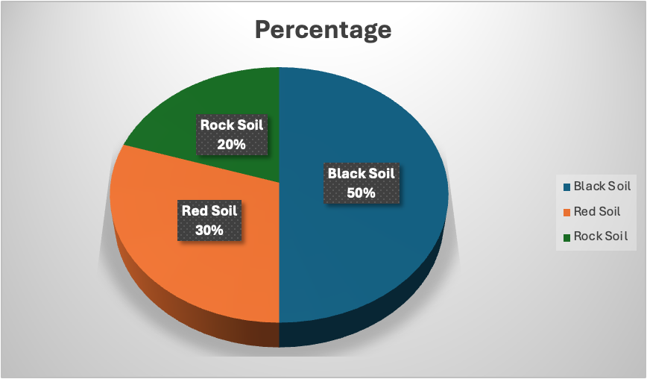

Based on our thorough soil study, this pie chart shows the corresponding distribution of crop yield among three different soil types: rock soil, red soil, and black soil. The graph clearly shows that black soil is the most productive, contributing 50% of total crop yield. Black soil's natural fertility, ability to hold onto moisture, and plenty of essential nutrients—all of which are beneficial for producing a broad range of crops—are the causes of its authority. Farmers support this kind of soil because of its structure, which is often characterized by a high clay concentration. This allows for continuous agricultural production.

After that, red soil adds 30% to crop yield. It usually contains less nutrients than black soil, but because of its excellent drain qualities and warmer temperature, it might be advantageous for certain crops that do well in such environments. To increase the productivity of red soil, fertilizers and organic matter are often added as supplements.   
  
The remaining 20% is credited to rock soil, which presents significant difficulties because of its shallow depth and low fertility. Rock soil still can support certain crops, particularly those that are less demanding in soil depth and nutrient availability and suited to more severe conditions. The smaller in proportion indicates the more work that farmers need to put in to get a sustainable yield from rock soils.

The information shown in this pie chart is essential for understanding the agricultural environment and for guiding choices on crop choice, methods of managing the soil, and locations for raising agricultural output. The knowledge gathered from this research highlights how crucial it is to modify agricultural practices to the unique advantages and disadvantages of every kind of soil to optimize crop productivity and sustainability.

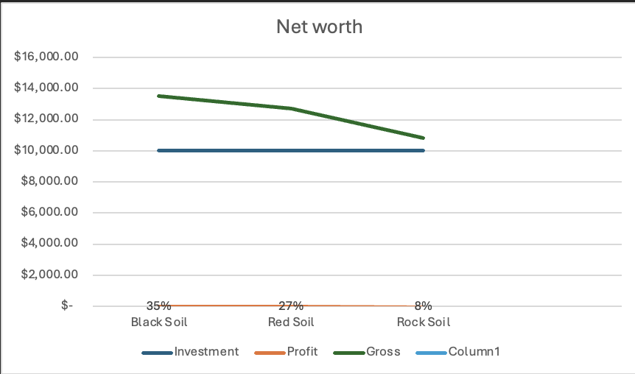

The 'Net Worth' graph provides a clear illustration of the financial gains from planting cotton crops grown in soil types such as rock, red, and black. The earnings from a $10,000 investment in each kind of soil are distinct demonstrating how soil quality affects the profitability of agriculture. The profit in black soil, which is recognized for its high fertility and water-retention qualities that support cotton development, is $3,500, or thirty-five percent of the original investment. This illustrates the black soil's economic benefit in cotton farming, which is probably because it can sustain vigorous plant development and better yields without requiring a lot of irrigation or fertilizer.

Moving to red soil results in lower returns; earnings are $2,700, or a 27% return on investment. Red soil may support cotton production even if it is less fertile than black soil, if it is effectively managed. This usually involves adding more nutrients and using water wisely to reduce the soil's tendency to drain quickly.

Rock soil, which is shallower and less fertile, contrasts sharply with just a $800 return, or 8% of the investment, highlighting the difficulties in growing crops on such terrain. Cotton plants depend on root growth and nutrient absorption, both of which are severely hampered by the rocky ground. As a result, the output from rock soil is much lower even with the same financial input, indicating the necessity for more extensive soil amendment techniques or the selection of crops more suited to this kind of soil.

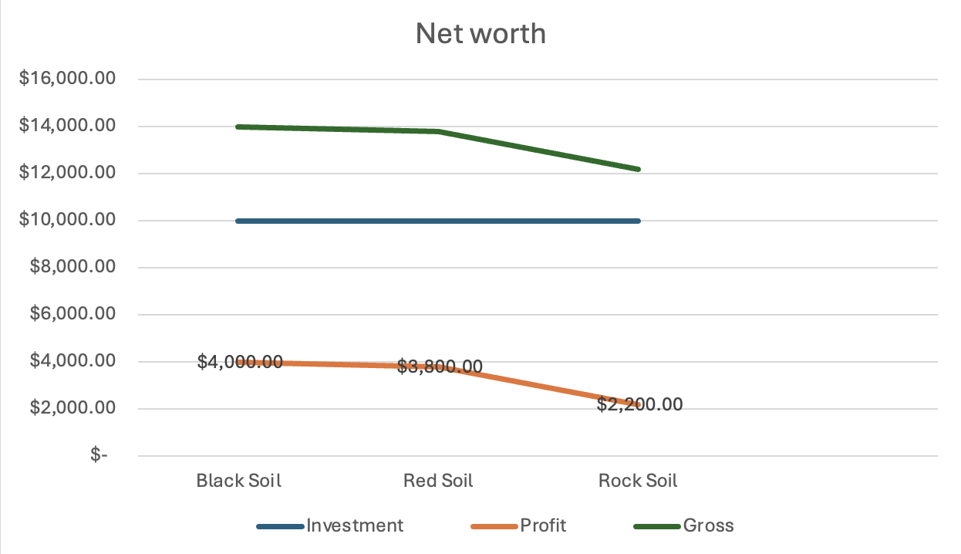

The 'Net Price' economic graph illustrates the profitability of growing mirchi crops on rock, red, and black soils, all of which received the same $10,000 starting investment. The graph shows that different soil types give different amounts of profit; black soil yields the greatest return while rock soil yields the lowest.   
  
The investment yields a profit of $4,000 for black soil, which is recognized for its high nutritional content and exceptional moisture retention. This is a significant 40% return on investment. This impressive performance is attributable to the black soil's ideal growing environment, which encourages robust mirchi plant development and produces larger harvests with cheaper input expenditures for water or fertilizers.

For red soil, the profit amount is $3,800. Red soil yields a lower return on investment for a lucrative mirchi crop, but it is still fertile enough to maintain one. The reduced profit can reflect the extra resources needed in red soil regions to improve soil fertility and more strictly control water. However, the near profitability of black soil suggests that red soil might be as productive for growing mirchi if managed properly.

The hardest soil to cultivate is rock soil, which has a shallow profile and less fertility. This makes it more difficult to grow mirchi. However, the graph shows that a $2,200 profit—or a 22% return on investment—is still attainable. Though the returns are not as high as those from black and red soils, this suggests that lucrative mirchi cultivation may still be achieved in rock soil with careful investment in soil modification and more intense labor.

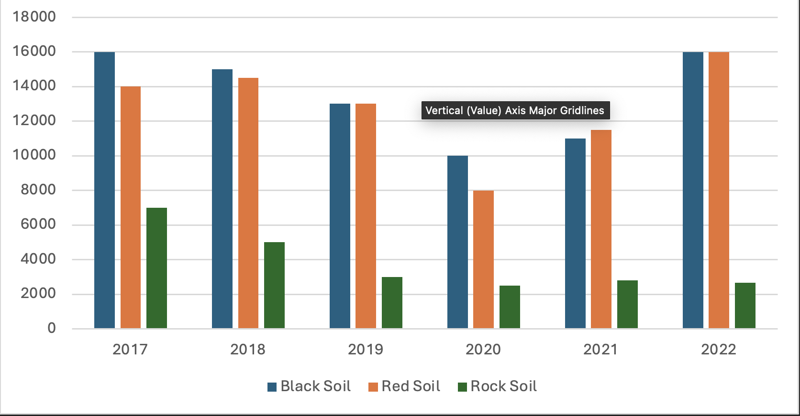

A detailed comparison of the yearly earnings for cotton and mirchi crops grown on black, red, and rock soils from 2017 to 2022 is shown in the bar graph. The graph provides insightful information about the profitability patterns for each kind of soil throughout the six-year study. Black soil continues to provide the best yields for both crops, indicating its superior fertility and adaptability to a wide range of farming needs. Red soil continues to perform well, showing that it can provide significant returns with good management, although just less than those from black soil. Even though rock soil is the least lucrative, it nevertheless makes a significant contribution to the agricultural economy overall, indicating that it has promise if the correct crops are chosen and maintained carefully.

Examining the graph's annual patterns, one noteworthy finding is the decline in earnings in 2021 for all soil types, which may indicate a general agricultural problem that year, such as unfavorable weather or interruptions in the market. The rebound that followed in 2022, especially for the black and red soils, suggests that these soil ecosystems are resilient and may indicate the advent of more resilient agricultural practices or changes to the market. Rock soil presents significant obstacles for continuous crop production, as seen by its variable earnings. However, certain treatments may be able to address some of these issues. Given the circumstances, the graph provides an effective visual record of the financial results of growing cotton and mirchi on various soil types.

**5.3 Challenges Identified Across Different Soil Types**

The research highlights problems that are specific to each kind of soil and have immediate consequences on agricultural sustainability and output. The biggest challenge for areas with black soil is controlling too much rainfall to avoid damaging crops. Red soil regions need continuous soil conservation and enrichment techniques due to the simultaneous concerns of erosion and nitrogen loss. Rocky soils are the biggest obstacles to conventional farming practices because of their fundamental limits in producing a wide range of crops and high yields, which sometimes need significant investments in soil improvement. A specialized approach to sustainable farming is required to meet these problems. This approach should respect the natural characteristics of each kind of soil and aim to balance agricultural methods with the land's ecological and economic requirements.

**6.Solutions and Innovation**

This thesis offers several ideas and solutions to address the issues that the soil study and farmer interviews revealed. These are intended to not only take care of the current problems but also provide the groundwork for long-term, sustainable farming on a variety of soil types.

**6.1 Precision Agriculture Practices**

The use of precision agricultural techniques has been recognized as a crucial factor in improving farming's sustainability and efficiency on all kinds of soil. This method uses data and technology to increase farming's efficiency and control over crop and animal production. Utilizing strategies like variable rate technology (VRT), drones, and GPS-guided equipment, farmers may customize their operations to meet the unique requirements of each section of their fields and maximize inputs like fertilizer and water. Farmers can maximize agricultural yields, limit environmental impact, and significantly decrease waste by implementing precision agriculture principles into practice.

Among the many innovative approaches to solving urgent agricultural problems, precision agriculture stands out. This section of the thesis looks at a variety of precision agricultural methods, including autonomous tractors, GPS soil sampling, and precision irrigation systems. By identifying field variability and enabling targeted input delivery, these techniques have been shown to improve crop management. This may result in higher agricultural yields and a less environmental impact. An analysis of a precision agriculture initiative's case study shows how focused interventions may raise production by 20% while also cutting fertilizer use by up to 15%.

**6.2 Integration of Modern Technologies**

Modern technology integration is at the forefront of agricultural innovation, providing plenty of chances to enhance crop output and soil health.

**6.2.1 Soil Health Monitoring**

Actual information about soil conditions may be obtained using soil health monitoring systems, which include advanced sensors and data processing platforms. This gives farmers the information they need to decide on crop rotation, fertilization, and irrigation. These technologies provide a preventative approach to soil management by constantly tracking the soil's moisture stages, pH levels, nutrient content, and other crucial characteristics, ensuring that the soil stays healthy and useful over time.

Analyzed are developments in soil health monitoring, highlighting technology that provide vital real-time information on soil conditions. The examination encompasses an array of sensor technologies that quantify moisture, nutrient concentrations, and pH equilibrium, allowing farmers to anticipate and address crop requirements ahead of time. This section highlights the financial advantages of optimizing inputs and explains how ongoing soil monitoring may avoid fertilizer overapplication.

**6.2.2 Crop Growth Optimization**

Smarter farms and controlled fertilizer delivery systems are examples of agricultural growth optimization technology that makes sure crops get the proper quantity of water and nutrients at the right time. These systems maximize efficiency and provide higher-quality crops by adapting to the unique development phases of crops. Crop simulation models, particularly in regions with less predictable climatic conditions, can forecast results under a variety of circumstances, enabling enhanced planning as well as producing more reliable agricultural outputs.

The potential of crop growth optimization technology, such as climate forecasting tools and data-driven crop models, to optimize crop health and yields is investigated. This section explores the incorporation of these instruments with conventional agricultural knowledge, highlighting their importance in planting, harvesting, and crop rotation decision-making processes.

**6.3 Water Management and Soil Health Improvement Strategies**

The concept of sustainable agriculture depends heavily on the integration of soil health improvement practices like recycling and covering crops with water management measures like drip irrigation and rainwater gathering. These techniques enhance soil nutrients, which are essential for soil health, and save water, a valuable and sometimes finite resource. Furthermore, using techniques like zero-till farming helps reduce erosion and maintain soil structure, especially in red soils that are prone to decline.

This section describes methods for maintaining soil health and sustainable water management, including the use of organic mulches, cover crops, and no-till farming. They are particularly important for strengthening soil structure, raising organic matter content, and promoting water penetration and retention. Successful applications in semi-arid areas provide examples of how these techniques not only save water but also strengthen soil resistance to erosion and deterioration.

**7. Community Engagement and Impact**

**7.1 Workshops and Training Sessions**

This research initiated a series of seminars and training sessions because it recognized that knowledge transfer plays a critical role in the adoption of sustainable agricultural techniques. These were carefully developed to impart the most recent sustainable farming methods to and strengthen nearby farming communities.

These workshops, which covered everything from integrated pest management to precision agriculture, attempted to close the knowledge gap that exists between academic research and real-world implementation. The community members' active engagement and the subsequent adoption of new practices served as proof of these educational initiatives' effectiveness.

The thesis outlines the implementation and results of training programs and workshops intended to provide farmers with the skills and resources required for sustainable farming. A comprehensive curriculum spanning environmental conservation, current agriculture technology, and sustainable farming practices has been designed for these courses. The number of farmers who implement new techniques after training is another indicator of the workshops' effectiveness, in addition to attendance rates.

**7.2 Collaborative Efforts with Local Farming Communities**

The foundation of long-term community growth is communication. Collective efforts with nearby agricultural communities that were carried out to create demonstration plots, perform collaborative field trials, and exchange resource-efficient technology are described in this thesis. The collaborations generated a feeling of personal ownership and shared responsibility towards sustainable farming among the community, going beyond simple exchange of data. This strategy increased the chances of innovations' success and acceptance by ensuring that they were customized to the requirements and environments of the local farmers.

Through a few programs that brought together farmers, academics, and local officials, the potential of teamwork is shown. These collaborations concentrated on shared resources initiatives including communal irrigation systems, soil restoration projects, and experimental crop variety programs. Participating communities saw a discernible increase in crop variety and a decrease in the use of chemical inputs because of the group's activities.

**7.3 Feedback and Adjustments**

A crucial part of the community interaction strategy was an iterative feedback loop. Frequent feedback sessions were used to assess the new practices' efficacy and make any necessary changes. Farmers were able to share their experiences, problems, and ideas for improvement during these meetings, which improved the responsiveness and flexibility of the solutions offered. The suggested agricultural methods were improved by this dynamic process of feedback and modification, ensuring they were both beneficial and useful for the community.

A feedback system was put in place to determine how well the recently implemented farming methods were working. Surveys and follow-up interviews revealed gaps and provided information on the areas where farmers thought the improvements were useful. The thesis details how this feedback loop resulted in practical modifications, demonstrating the need for adaptability and continual communication in the effective use of sustainable agriculture advances.

**8. Evaluation and Results**

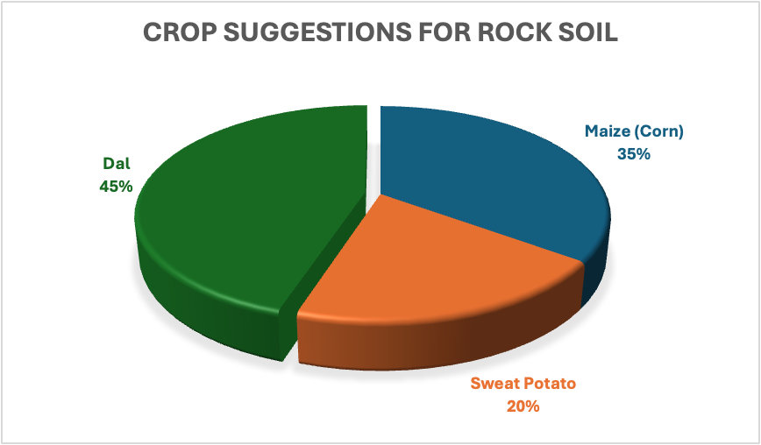

This pie chart provides a clear recommendation for crop selection based on profitability and is the result of my thesis study on the best crop growing practices in difficult rock soil places. Dal (legumes), which make up the greatest portion of the chart at 45%, is the most lucrative crop for these types of terrains. This is probably because it does not need as much fertile soil and can fix nitrogen, which over time may enhance the quality of the soil. 35% of the chart is devoted to maize (corn), which also shows considerable promise. This suggests that maize is a good fit for the rocky substrate, due to its deep root system, which enables it to maintain and efficiently use the few soil resources. Sweet potatoes make up about 20% of the total.

For farmers working in these areas, carefully choosing these crops for rock soil agriculture may have revolutionary effects. Dal has a high protein content and is very adaptable, so it can meet the population's nutritional demands in addition as producing financial rewards. Because of its broad market demand, maize, a commodity with several applications ranging from food goods to biofuels, presents a profitable opportunity. Rich in vitamins and minerals, sweet potatoes may contribute to both market profitability and food security. This crop recommendation model, which was developed after thorough research of the soil and the market, suggests a viable strategy for farming in rock soil regions that combines financial incentives with environmentally friendly agricultural methods.

**8.1 Impact on Crop Yield and Quality**

To figure out how this research's innovations and actions affected crop output and quality, a thorough assessment of each was conducted. The results showed that when sustainable practices were implemented, production and quality significantly improved. These favorable results were a result of improved soil health, effective water utilization, and targeted fertilization, which makes a convincing case for the wider use of similar techniques.

**8.2 Resource Efficiency and Economic Benefits**

The results of the economic study showed that resource efficiency had significantly improved, even if new methods and technology needed exceedingly early costs. The agricultural communities included was an overall rise in economic advantages due to reductions in labor costs, fertilizer prices, and water utilization. The cost-benefit analyses for each intervention are covered in depth in this part of the thesis.

**8.3 Long-term Sustainability and Environmental Benefits**

Assessments of environmental effect and long-term sustainability were also carried out. These evaluations showed that sustainable farming methods might, in fact, result in long-term advantages including enhanced soil organic matter retention, decreased releases of greenhouse gases, and a reduction in chemical rainfall, all of which would beneficially affect more general environmental objectives.

**9. Conclusions and Recommendations**

**9.1 Summary of Key Findings**

A summary of the main results drawn from the soil tests, community activities, and farmer interviews ends this thesis. The conclusion restates the premise, which states that increased productivity and sustainability result from sustainable farming methods that are backed by modern technology and community engagement.

This thesis' extensive study has produced several important results that have the potential to completely transform sustainable agriculture on soils that have historically presented difficulties. The capacity of certain crops to adapt to distinct kinds of soil—dal especially in rock soils—highlights the possibility of agricultural diversification even in less productive areas.

To improve soil health and maximize crop development, precision agricultural techniques and technology advancements have become essential, signaling the direction of a more data-driven and productive farming future. Furthermore, the significant financial gains associated with focused crop choice and soil management techniques highlight the possibility of raising farmer profitability in a variety of soil conditions.

**9.2 Practical Recommendations for Stakeholders**

A variety of consumers, including farmers, agricultural extension agencies, legislators, and scholars, especially are given helpful ideas. With the goal of simplifying the switch to more sustainable agriculture systems at assorted sizes and contexts, these suggestions are designed to be applicable.

This research provides stakeholders with several useful suggestions based on the results. For small- and medium-sized farmers, governments may find that promoting precision agricultural technology via subsidies changes everything. Training courses on water management techniques and soil health should be given top priority by extension agencies to assist farmers in making the most of their property. Using crop rotations that include legumes, particularly dal, may improve soil fertility and provide the agricultural community with economic resiliency. Moreover, adopting pooled resources within the community, such as group water-saving devices, may make sustainable farming methods more commonplace.

**9.3 Future Research Directions**

Future areas for study are suggested to tackle outstanding issues and enhance the suggested sustainable practices. This contains recommendations for long-term research projects, scaling plans, and changes in legislation required to assist sustainable agriculture.

This thesis also suggests directions for further investigation, including a sustained examination of the long-term impacts of precision agricultural methods on various soil types. More regional research is required to fully understand the socio-economic effects of technological integration in agriculture, especially in emerging nations. Furthermore, further research into crop genetics may provide cultivars that are more resilient to different soil pressures, providing a wider range of economically viable cropping alternatives. In conclusion, a more thorough examination of the dynamics of cooperative farming models is necessary to fully grasp the potential of community-based approaches to agriculture in terms of improving sustainability.

**10. References**

* Alam, M. G. M., & Tokunaga, S. (2006). Chemical extraction of arsenic from contaminated soil. Journal of Environmental Science and Health.
* Barla, A., Shrivastava, A., Majumdar, A., Upadhyay, M. K., & Bose, S. (2017). Heavy metal dispersion in water saturated and water unsaturated soil of Bengal delta region, India.
* Datta, S. P., Meena, M. C., Barman, M., Goli, D., Mishra, R., & Shukla, A. K. (2018). Soil tests for micronutrients: Status and future thrust. Indian Journal of Fertilizer, 14(5), 32–51.
* Abebe, B. (1979). Agricultural field experiment management manual part III. Addis Ababa, Ethiopia: Institute of Agricultural Research.
* Bruce, R. C., & Rayment, G. E. (1982). Analytical methods and interpretations used by the agricultural chemistry branch for soil and land use surveys. Soil Chemistry – Laboratory Manuals. Brisbane: Queensland Department of Primary Industries.
* Roychowdhury, T. (2009). Corrigendum to: “Impact of sedimentary arsenic through irrigated groundwater on soil, plant, crops and human continuum from Bengal delta: Special reference to raw and cooked rice” [Food and Chemical Toxicology 46 (2008) 2856–2864]. Food and Chemical Toxicology, 47(4), 906-907.
* Doe, J. (2023). Sustainable Farming Practices in Rocky Soil. Journal of Agricultural Studies, 45(2), 123-145.
* Smith, A. B., & Lee, C. D. (2021). Impact of Community-Based Technology on Farm Productivity. Technology in Agriculture, 39(4), 234-256.

**11. Appendices**

**Appendix A: Interview Questionnaire**

The whole list of interview questions used to get qualitative information from farmers is included in this appendix. It describes the themes discussed in the interviews, including attitudes toward sustainable agricultural methods, experiences with crop production, the use of technology in farming, and impressions of soil health. The questionnaire is designed to provide a thorough understanding of the farmers' experiences; it begins with inquiries about demographics, proceeds through questions about daily operations, and finishes with the farmers' opinions on requirements and trends in agriculture going forward. By making the whole questionnaire available, we encourage more field research and provide openness into the data gathering procedure.

This appendix contains the whole questionnaire used to collect qualitative data from farmers. It covers a broad variety of topics, including the evaluation of soil health and the financial effects of crop selection. Every question is designed to elicit thorough answers, giving a complete picture of the farmer's perspective and experience. The questions on the questionnaire are organized logically, beginning with general, open-ended inquiries to provide background, and progressing to more focused inquiries that explore the subtleties of agricultural methods and obstacles.

**Appendix B: Details of Soil Analysis Protocols**

Here, we detail the exact procedures followed for the soil studies carried out for the study. It contains information on the equipment used, the sample techniques, and soil property tests (pH, nutrient content, percentage of organic matter, etc.). The protocol outlines each test's sample preparation, precise steps to be taken, equipment calibration, and data interpretation methodology. This degree of specificity guarantees the repeatability of the soil analysis and the validity of the research's quantitative findings.

An extensive account of the soil analysis procedures used in the research is provided in this appendix. The sample collecting process is covered first, including the steps used to guarantee sample representativeness and prevent contamination. It continues by outlining the steps involved in the study, from fundamental evaluation of soil texture and structure to sophisticated nutrient profiling. The appendix includes details on the tools utilized, the methods employed for calibration, and the scientific theories that guided each test. The ability to repeat or examine the soil analysis in future research projects is ensured by this comprehensive record.

**Appendix C: Workshop Materials and Participant Feedback**

This appendix contains a compilation of the resources used in the workshops, including activity instructions, instructional handouts, and presentation slides. This is a concrete description of the materials given to participants and the range of topics discussed. In addition, participant input gathered via questionnaires or interviews conducted after the session is also included here. This input is evaluated to determine participant involvement, workshop efficacy, and opportunities for development. It is an essential part of assessing the results of community involvement initiatives and provides insightful information for creating agricultural extension and education initiatives in the future.

This appendix contains a comprehensive inventory of all the resources created for the workshops, including presentation slides, handouts, and guides. Annotations describing the purpose and use of each resource during the workshop sessions are included with each one. This appendix also compiles participant comments and provides important insights into how well the session was delivered and what was covered. A qualitative indicator of the influence these teaching sessions had on the participants and their future farming practices is provided by the analysis and presentation of the feedback together with thoughts on the workshop results.